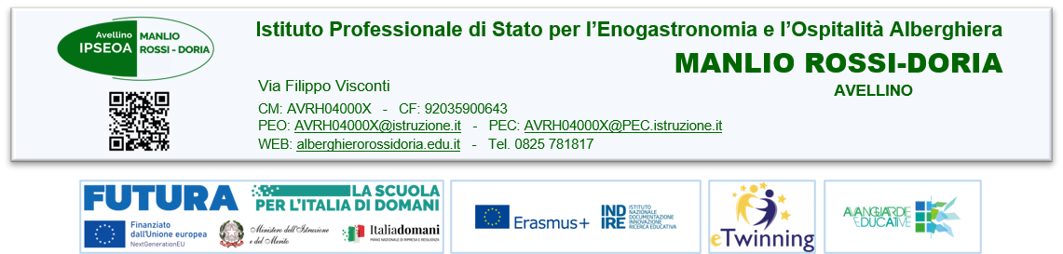

- ALLEGATO 3B
- MOTIVATION LETTER
- PROGRAMMA ERASMUS+ - AZIONE KA121

ACCREDITAMENTO IPSEOA MANLIO ROSSI- DORIA” Progetto n. 2023-1-IT01-KA121-VET -000117297- CUP C39B23000110001

Complete the form by typing (max two pages)
Explain why are you interested in the project and specify the activities and interests for which you have more qualifications, knowledge and skills:

Avellino, 2024
Candidate’s signature

